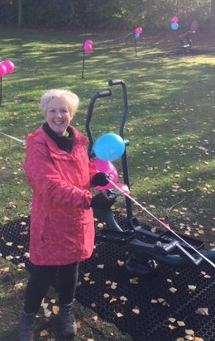
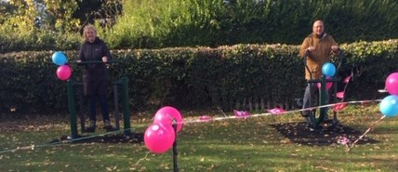
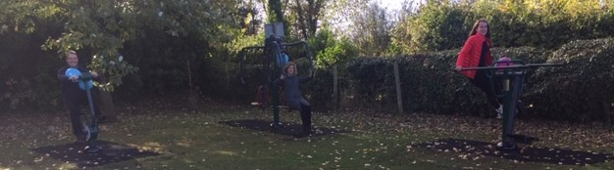
THE PHOTOGRAPHS FROM THE 28TH OCTOBER SHOW THE CLERK OFFICIALLY CUTTING THE RIBBON AND DECLARING THE NEW EQUIPMENT OPEN AND READY FOR USE. MEMBERS OF THE COMMUNITY WERE SOON PRACTISING THEIR KEEP FIT SKILLS.
THE BIG LOTTERY FUND AWARDED THE PARISH COUNCIL A GRANT OF £8518 SECURING THE PURCHASE OF SIX PIECES OF EQUIPMENT WHICH HAVE BEEN FITTED IN THE PLAY AREA, BIRMINGHAM ROAD, WHITACRE HEATH.
THE IDEA OF ADULT GYM EQUIPMENT IN OUR PLAY AREA CAME FROM A LOCAL RESIDENT. WE DECIDED TO HOLD AN EXHIBITION WITH PICTURES OF OUTDOOR GYM EQUIPMENT AND HAD AN EXCELLENT RESPONSE. MEMBERS OF THE COMMUNITY WERE ASKED TO CHOOSE THEIR FAVOURITE SIX PIECES FROM THE PICTURES ON DISPLAY AND THEIR ENTHUSIASM RESULTED IN THE COUNCILLORS DECIDING TO APPLY FOR A GRENT.
MANY RESIDENTS AGREED THAT THEY WOULD USE THE ITEMS AS IT CAN BE DIFFICULT TO GET TO A GYM FROM THE VILLAGE. THE OLDER GENERATION HAVE MOBILITY AND TRANSPORT ISSUES, PARENTS AND GRANPARENTS SAID THEY WOULD LIKE TO USE IT WHILE THEIR CHILDREN PLAY IN THE PLAYGROUND. RESIDENTS FROM NEIGHBOURING VILLAGES PROPOSE TO USE IN AS PART OF THEIR FITNESS REGIME, JOGGING TO THE PLAY AREA, USING THE EQUIPMENT AND JOGGING HOME.
WE HOPE THIS WILL HAVE A POSITIVE IMPACT ON THE WHOLE OF THE COMMUNITY.
MANY THANKS AGAIN TO THE BIG LOTTERY FUND FROM NETHER WHITACRE PARISH COUNCIL

